Project Specification Document

--------------------------------------------------------------------------------------------------- **Document Version 1.0** **Latest updated: 12-04–2022**

**Author: Mohammed Musthaq S**

**Online Test Application**

**Content**

**1. About this Document------------------------------------------------------------1**

**1.1 How this Document is organized-------------------------------------1**

**1.2 Contact Information----------------------------------------------------2**

**2. Introduction------------------------------------------------------------------------3**

**2.1 Objectives------------------------------------------------------------------3**

**3. Flow chart--------------------------------------------------------------------------4**

**3.1 Flow chart diagram--------------------------------------------------------4**

**4. Solution Overview-----------------------------------------------------------------4**

**5. GitHub link-------------------------------------------------------------------------4**

1. **About this Document**

This functional and integration (FIS) document will enable you to understand the proposed solution of OnlineTestApplication.com

The content of the document will have a solution and its configuration details as it will be available for our client.

**1.1 How this Document is organized**

This document is organized into following chapters:

**Chapter 1 -** "Introduction" provides solution scope to be delivered to our client.

**Chapter 2 -** "Flow chart" provides how the user is interacting with the application.

**Chapter 3 -** "Solution Overview" provides information on Online Test Application Pvt. Ltd., Components and Interfaces in system.

**Chapter 4- “GitHub link”** provides the information where the project is located.

**1.2 Contact Information**

Online Test Application App invites your comments and suggestions on the quality and usefulness of this document.

**2. Introduction**

This document describes the implementation of *Online Test Application* and how its users can interact with the application.

*Online Test Application is a portal that has Quiz Test Module in it.*

*The system provides its user to participate in a quiz competition and can see its output and review for attended Quiz.*

**2.1    Objectives**

*The Online Test Application system creates an application that enables users to provide online tests, review them, and display the results.*

This system contains three main modules: Quiz, Review, and Result. The quiz section of the online test application accepts the questions in JSON format. The JSON file can be easily shared from the server in the pre-defined format. The application renders the test at the client-side.

The “Review and display result” section allows users to declare the results immediately. You can simply call another JSON with the answers in it and evaluate and display the results immediately.

**3. Flow chart**

**3.1** The objective of this session to show how the user can start Quiz Test*.*

Start Page of Online Test Application

User’s Review Card and Score Card of Quiz Test Application

Finish the Quiz Test App

**4. Solution Overview**

**Platform requirement**

The platform used for this project is the VS Code and Angular CLI Version of Angular CLI: 13.2.6

Node: 16.14.0

**Now if a user clicks anywhere on the application, then bydefault user will get landed on start page of Online Test Application.**

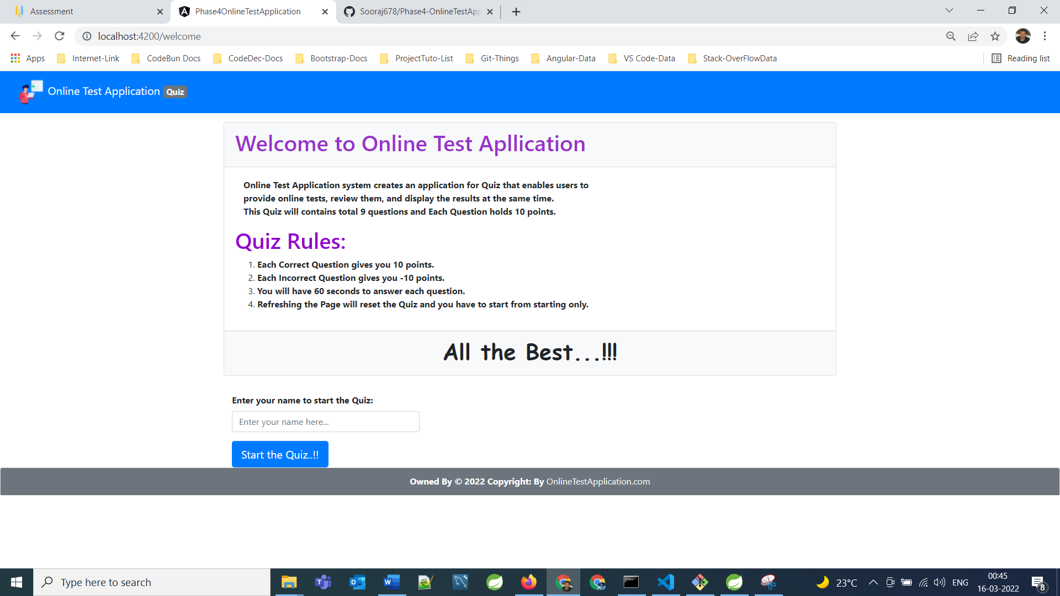

**5. GitHub link**

This section link where the source code is located and from where the user can download and use it.

**https://github.com/musthaqmd/Simplilearn-phase-4.git**